Copyright © 2008 Welocalize, Inc.
Copyright © 2008 Welocalize, Inc.
www.globalsight.com
Copyright © 2008 Welocalize, Inc.
Open source initiative for
managing, translating &
delivering global content

GlobalSight Adapter Design

GlobalSight 7.1

Table of Contents

1.Overview 3
1.Definitions 3
2.Use Cases 3
1.Use Case 1 – Admin/PM imports a document 3
2.Use Case 2 – Admin/PM exports a document 3
3.Design Overview 3
1.Introduction 3
1.1.UI Interaction 3
4.Object Model 4
1.Converter side 4
2.GlobalSight side 4
2.1.Import a job 4
2.2.Export a job 5
5.Deployment Considerations 5
1.Database script updates 5
2.JMS configuration 6
2.1.Jboss.xml 6
2.2.GlobalSight-JMS-service.xml 7
2.3.Ejb-jar.xml 7
2.4.Class locations 8
6.Dependency API 10
1.Existing classes that you do not need to modify 10
1.1.BaseAdapterMDB 10
1.2.BaseAdapter 10
2.Existing classes that you do need to modify 10
2.1.EventTopicMap 11
2.2.CxeMessageType 11
3.Newly added classes 11
3.1.NewlyDevelopedSourceAdapterMDB 11
3.2.NewlyDevelopedTargetAdapterMDB 11
3.3.NewlyDevelopedAdapter 12
7.Sample Code 13
1.1.NewlyDevelopedSourceAdapterMDB 13
1.2.NewlyDevelopedTargetAdapterMDB 13
1.3.NewlyDevelopedAdapter 14

Overview
GlobalSight itself does not have the ability to read content from binary documents like Word and InDesign, since Java is not good at using the application’s API to deal with the proprietary document format. The GlobalSight adapters have been developed to help GlobalSight read and write customer content from various formats to the common formats XML or HTML, which GlobalSight can then easily extract for importing/exporting a job.

Definitions
Adapter
Converter
JMS (I realize most developers know what these next two are, but it wouldn’t
MDB

Use Cases
This section details two main use cases for converter working with GlobalSight.

Use Case 1 – Admin/PM imports a document
When Admin/PM imports a document whose format GlobalSight does not understand, it puts the document into the directory that the converter is watching. The converter then starts to convert the document to XML or HTML by using the APIs of the corresponding application. After this, GlobalSight gets the converted XML or HTML file to the system and creates a job with it.

Use Case 2 – Admin/PM exports a document
When Admin/PM exports a job/workflow that was created with the converter, GlobalSight puts the XML or HTML to the directory that the converter is watching, then the converter starts to convert the XML or HTML to the original document by using the APIs of the corresponding application. After this, GlobalSight gets the converted document to the system and exports the job/workflow with it.

Design Overview

Introduction
- The converter requires the implementation of watching a directory and converting from or to XML or HTML files according to the application’s own APIs.
- GlobalSight requires the sending of JMS message to the adapter mdb according to its event type.
- The adapter is invoked by the adapter mdb.
- The adapter performs handling the conversion by putting the imported or exported file into the directory that the converter is watching.
- The adapter communicates with the converter to do the conversion (from original format file to XML/HTML or from XML/HTML to the original format file).
- After the conversion is finished, which means the converted file (XML/HTML/original format file) is generated, the converter needs to tell GlobalSight that the conversion is done and then GlobalSight will take the converted file or return error message to the system for the left import or export processes.

UI Interaction
Add a new source file format to the system.

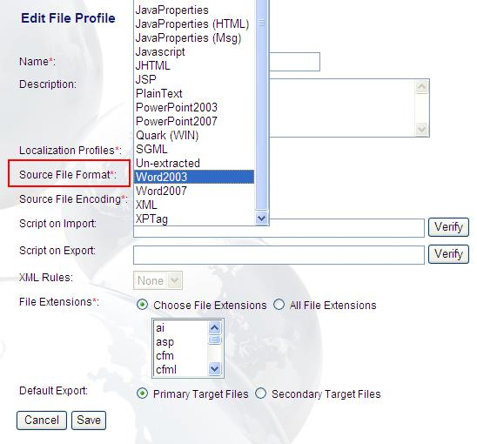
Figure 1 – A list of existing Source File Format in the system.

Object Model
This section addresses the converter itself on C# or C++ side, and how it works with the GlobalSight side called adapter at the implementation level.

Converter side
The converter needs to implement the following functions.
1) Watching a directory. The files in the directory or sub-directory should be watched all the time when it is running.
2) Communication with GlobalSight adapter before the conversion.
- The way of communication between them can be designed as you like, but the purpose is when the GlobalSight adapter puts the imported or exported file(s) into the watched directory.
- The GlobalSight adapter first tells the converter what process it is now and the converter is able to read some information from GlobalSight adapter and understand which conversion it needs to do (if it is an import process, the conversion should be from original format file to XML/HTML, if it is an export process, the conversion should be from XML/HTML to the original format file).
3) Start the conversion.
- After the conversion type is determined in step 2), the converter is required to search the file brought by GlobalSight adapter in the watching folder and then starts the conversion.
- If the conversion type is from original format file to XML/HTML(import process), the converter needs to extract the content of the original format file to XML or HTML using the APIs that can handle the extraction.
- For example, for an original format Word file, the word converter needs to extract the content of the Word file to an HTML file using the Word application’s own APIs which can easily operate the Word application to do the extraction to HTML in C# language.
- If the conversion type is from XML/HTML to original format file(export process), the converter will need to put the translated XML or HTML back to the original format file using the APIs that can handle that. For the Word file, the Word application also has useful APIs to do the conversion in C# language.
4) Communication with GlobalSight adapter after the conversion.
- After the conversion is finished, the converter needs to tell GlobalSight adapter the conversion is finished successfully or not. During 3).
- GlobalSight adapter should be waiting for the conversion to be finished and after the conversion is finished, it reads some information from the converter and understands the conversion is successful or not.
- Based on the result, GlobalSight adapter gets the converted file back or return some error message to the system for the left processes.

GlobalSight side
The GlobalSight adapter is working with the converter for two major processes including “Import a job” and “Export a job”.

Import a job
In GlobalSight, for a file that needs a converter to process, after clicking the “Create Job” button, the basic workflow is as following:
- A JMS message comes to a MDB “FileSystemSourceAdapterMDB” which extends a super MDB “BaseAdapterMDB” of the adapters. In this stage,
- GlobalSight makes an event flow xml which records some information of the imported file.
- After that, the event flow xml(String) and the event type(CxeMessageType) for the new Adapter will be set to CxeMessage.
- Then CxeMessage will be wrapped to an AdapterResult array and return it to BaseAdapterMDB for left processes.
- BaseAdapterMDB looks for the next MDB topic (the new adapter) according to the event type(CxeMessageType) and sends the JMS message. After the new adapter receives the JMS message,
- it goes to BaseAdapterMDB first since the new adapter MDB (NewlyDevelopedSourceAdapterMDB) extends BaseAdapterMDB.
- Then BaseAdapterMDB searches the new adapter (NewlyDevelopedAdapter) and invokes the business method handleMessage() of it to start the work with converter.
- After the conversion is finished, the event type(CxeMessageType) should be set to XML_IMPORTED_EVENT (if the converted file is HTML, set the type to HTML_LOCALIZED_EVENT) and set the new type to CxeMessage and then wrap CxeMessage to AdapterResult array(AdapterResult[]) and return the array to BaseAdapterMDB for left processes.

Following sequence diagram shows the process of importing a job before JMS leaves the new adapter.

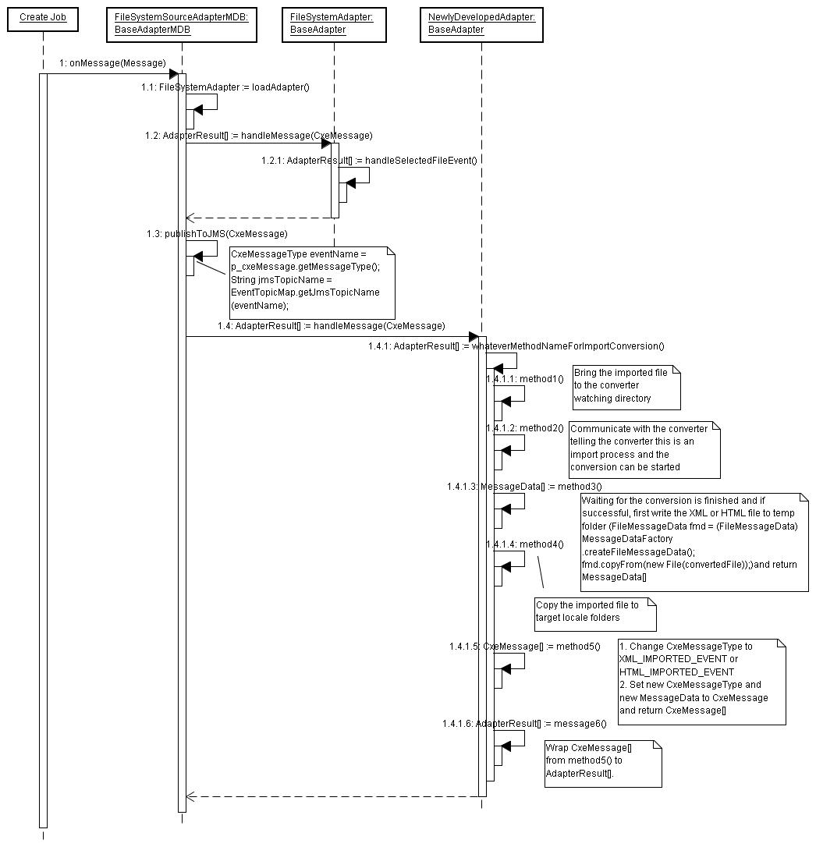

Export a job
In GlobalSight, for a file that needs a converter to process, after clicking the “Export” button, the basic workflow is as following:
- A JMS message comes to a MDB “CapSourceAdapterMDB” which extends a super MDB “BaseAdapterMDB” of the adapters. In this stage,
- GlobalSight parses the event flow xml which was created in the import stage.
- After that, the event flow xml(String) and the event type(CxeMessageType) for the new Adapter will be set to CxeMessage.
- Then CxeMessage will be wrapped to an AdapterResult array and return it to BaseAdapterMDB for left processes.
- BaseAdapterMDB looks for the next MDB topic (the new adapter) according to the event type(CxeMessageType) and sends the JMS message. After the new adapter receives the JMS message,
- it goes to BaseAdapterMDB first since the new adapter MDB (NewlyDevelopedTargetAdapterMDB) extends BaseAdapterMDB.
- Then BaseAdapterMDB searches the new adapter (NewlyDevelopedAdapter) and invokes the business method handleMessage() of it to start the work with converter.
- After the conversion is finished, the event type(CxeMessageType) should be set to XML_IMPORTED_EVENT (if the converted file is HTML, set the type to HTML_LOCALIZED_EVENT) and set the new type to CxeMessage and then wrap CxeMessage to AdapterResult array(AdapterResult[]) and return the array to BaseAdapterMDB for left processes.

Following sequence diagram shows the process of exporting a job before JMS leaves the new adapter.

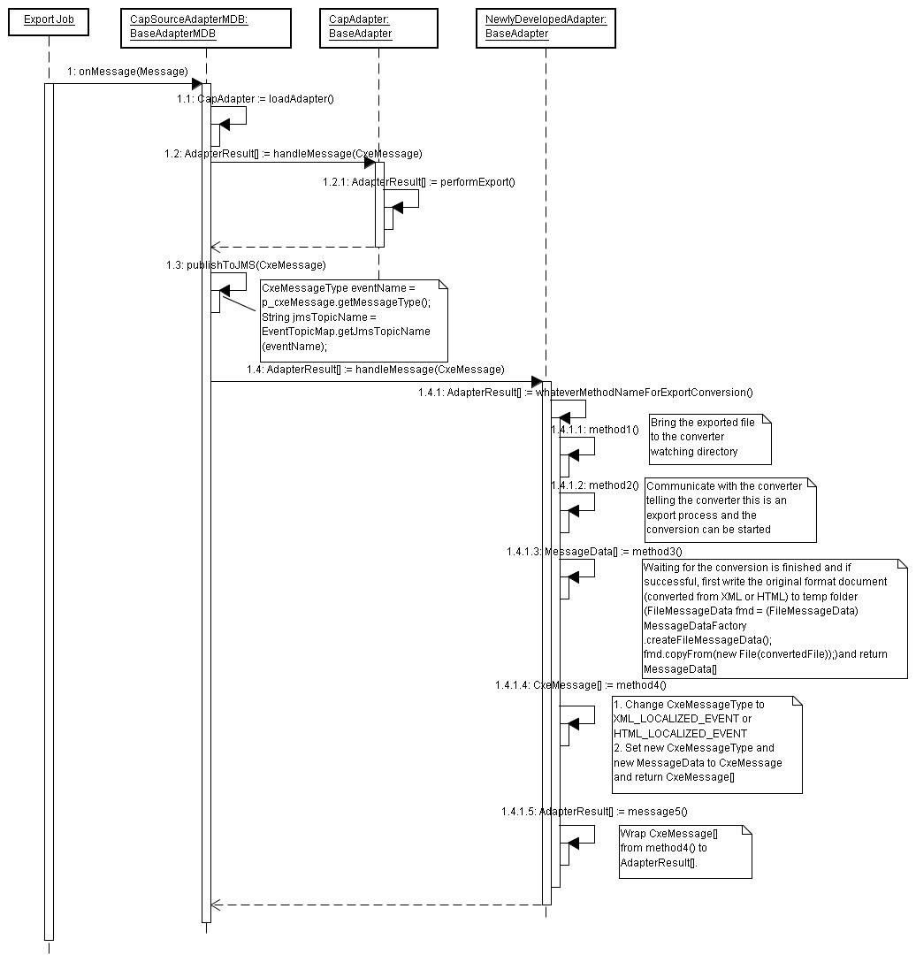

Deployment Considerations

Database script updates
To insert a new source file format to database, the following statements should be added to insert_known_formats_mysql.sql.
--adds a new source file format for a new adapter
INSERT INTO KNOWN_FORMAT_TYPE VALUES (
ID, 'NAME',' DESCRIPTION’,' FORMAT_TYPE',
'PRE_EXTRACT_EVENT',
'PRE_MERGE_EVENT'
);
Details for the columns:
ID: max(id) + 1
NAME: name of the new source file format, displaying in file profile – Source File Format
DESCRIPTION: description of the new source file format
FORMAT_TYPE: format type of the new source file format
PRE_EXTRACT_EVENT: the event type for the format document when importing. For example, the event type for the new adapter is NEW_IMPORTED_EVENT (used in above code)
PRE_MERGE_EVENT: the event type for format document when exporting. For example, if the converter is developed to convert the document to XML, the type should be XML_LOCALIZED_EVENT; if to HTML, the type should be HTML_LOCALIZED_EVENT.
Execute the newly added statements to update the database.

JMS configuration
Because the import and export operations are processed by JMS, the elated configuration files need to be modified.

Jboss.xml
#Location in code: main6\diplomat\dev\src\java\com\globalsight\cxe\adaptermdb\jboss.xml
#Location in server: GlobalSight_7.1\jboss\jboss_server\server\default\deploy\globalsight.ear\cxe-ejb.jar\META-INF\jboss.xml
<message-driven>
<ejb-name>NewlyDevelopedSourceAdapterMDB</ejb-name>
<destination-jndi-name>topic/com.globalsight.cxe.jms.ForNewlyDevelopedSourceAdapter</destination-jndi-name>
<jndi-name>com.globalsight.cxe.adaptermdb.new.NewlyDevelopedSourceAdapterMDB</jndi-name>
<mdb-subscription-id>NewlyDevelopedSourceAdapterMDB</mdb-subscription-id>
</message-driven>
<message-driven>
<ejb-name>NewlyDevelopedTargetAdapterMDB</ejb-name>
<destination-jndi-name>topic/com.globalsight.cxe.jms.ForNewlyDevelopedTargetAdapter</destination-jndi-name>
<jndi-name>com.globalsight.cxe.adaptermdb.new.NewlyDevelopedSourceAdapterMDB</jndi-name>
<mdb-subscription-id>NewlyDevelopedTargetAdapterMDB</mdb-subscription-id>
</message-driven>

GlobalSight-JMS-service.xml
#Location in code: main6\tools\j2eeVendor\jboss\util\GlobalSight-JMS-service.xml
#Location in server: GlobalSight_7.1\jboss\GlobalSight-JMS-service.xml; GlobalSight_7.1\jboss\jboss_server\server\default\deploy\GlobalSight-JMS-service.xml
<mbean code="org.jboss.mq.server.jmx.Topic" name="jboss.mq.destination:service=Topic,name=com.globalsight.cxe.jms.ForNewlyDevelopedSourceAdapter">
<depends optional-attribute-name="DestinationManager">jboss.mq:service=DestinationManager</depends>
</mbean>
<mbean code="org.jboss.mq.server.jmx.Topic" name="jboss.mq.destination:service=Topic,name=com.globalsight.cxe.jms.ForNewlyDevelopedTargetAdapter">
<depends optional-attribute-name="DestinationManager">jboss.mq:service=DestinationManager</depends>
</mbean>

Ejb-jar.xml
#Location in code: main6\diplomat\dev\src\java\com\globalsight\cxe\adaptermdb\ejb-jar.xml
#Location in server: GlobalSight_7.1\jboss\jboss_server\server\default\deploy\globalsight.ear\cxe-ejb.jar\META-INF\ejb-jar.xml
<message-driven>
<ejb-name>NewlyDevelopedSourceAdapterMDB</ejb-name>
<ejb-class>com.globalsight.cxe.adaptermdb.new.NewlyDevelopedSourceAdapterMDB</ejb-class>
<transaction-type>Container</transaction-type>
<message-driven-destination>
<destination-type>javax.jms.Topic</destination-type>
<subscription-durability>Durable</subscription-durability>
</message-driven-destination>
</message-driven>
<message-driven>
<ejb-name>NewlyDevelopedTargetAdapterMDB</ejb-name>
<ejb-class>com.globalsight.cxe.adaptermdb.new.NewlyDevelopedTargetAdapterMDB</ejb-class>
<transaction-type>Container</transaction-type>
<message-driven-destination>
<destination-type>javax.jms.Topic</destination-type>
<subscription-durability>Durable</subscription-durability>
</message-driven-destination>
</message-driven>

Class locations
Above configuration is assuming NewlyDevelopedSourceAdapterMDB and NewlyDevelopedTargetAdapterMDB are put at following path:
1. In server: GlobalSight_7.1\jboss\jboss_server\server\default\deploy\globalsight.ear\lib\classes\com\globalsight\cxe\adaptermdb\new
2. In code: main6\diplomat\dev\src\java\com\globalsight\cxe\adaptermdb\new
The NewlyDevelopedAdapter is supposed to be put at:
1. In server: GlobalSight_7.1\jboss\jboss_server\server\default\deploy\globalsight.ear\lib\classes\com\globalsight\cxe\adapter\new
2. In code: main6\diplomat\dev\src\java\com\globalsight\cxe\adapter\new

Dependency API

Existing classes that you do not need to modify

BaseAdapterMDB
BaseAdapterMDB is a base class for all adapter message driven beans to extend.
The related adapter class is loaded when BaseAdapterMDB is created. In ejbCreate() method, this.setAdapter(this.loadAdapter()) is called to specify the adapter to use to do the business logic.
In onMessage(Message msg), it invokes the adapter’s handleMessage(msg) method to make the business logic process.
After a process is done by an adapter, it gets the returned result AdapterResult[] to continue the next process of sending JMS message and receiving again. In publishToJMS(msg) method, it first gets the jms topic for the next MDB by
CxeMessageType eventName = msg.getMessageType(); //was set and returned in the first adapter.
String jmsTopicName = EventTopicMap.getJmsTopicName(eventName); //Need to add the new jms topic for the new adapter in EventTopicMap.java.
Then a new JMS message will be sent out to this JMS topic for the next process in the new adapter.

BaseAdapter
The BaseAdapter is a class that all adapters extend. It provides common methods for the adapters.
AdapterResult[] is returned when an adapter has successfully finished its process with following method.
AdapterResult[] makeSingleAdapterResult(CxeMessage p_cxeMessage)
You can also wrap exceptions for import in method
AdapterResult[] makeImportError(CxeMessage p_cxeMessage,GeneralException p_exception)
And wrap exceptions for export in method
AdapterResult[] makeExportStatus(CxeMessage p_cxeMessage,GeneralException p_exception)

Existing classes that you do need to modify

EventTopicMap
This class location in source code is: main6\diplomat\dev\src\java\com\globalsight\cxe\adaptermdb\EventTopicMap.java
New constants need to be added for the new adapter as following in construct method EventTopicMap()
fillMap(CxeMessageType.NEW_IMPORTED_EVENT, FOR_NEW_SOURCE_ADAPTER); //for import process
fillMap(CxeMessageType.NEW_LOCALIZED_EVENT, FOR_NEW_TARGET_ADAPTER); //for export process
The constants added in EventTopicMap are related with the destination-jndi-name configured in jboss.xml and GlobalSight-JMS-service.xml.
public static final String FOR_NEW_SOURCE_ADAPTER = " ForNewlyDevelopedSourceAdapter ";
public static final String FOR_NEW_TARGET_ADAPTER = " ForNewlyDevelopedTargetAdapter ";

CxeMessageType
This class location in source code is: main6\diplomat\dev\src\java\com\globalsight\cxe\message\CxeMessageType.java
Based on the change in EventTopicMap, new constants need to be added in CxeMessageType.
public static final int NEW_IMPORTED_EVENT = newid;
public static final int NEW_LOCALIZED_EVENT = newid+1;

Newly added classes

NewlyDevelopedSourceAdapterMDB
The source adapter mdb should extends the BaseAdapterMDB class and implement the two methods declared as abstract in BaseAdapterMDB.
abstract protected String getAdapterName();
abstract protected BaseAdapter loadAdapter() throws Exception;
The NewlyDevelopedAdapter should be returned in the implementation of method loadAdapter().

NewlyDevelopedTargetAdapterMDB
Because target adapter mdb invokes the same adapter as the source adapter mdb, the implementation could be the same as NewlyDevelopedSourceAdapterMDB.

NewlyDevelopedAdapter
The NewlyDevelopedAdapter handles conversions of new format file to xml/html using the new converter. For the implementation of this class, please get reference to the sequence diagram for import and export processes shown above.

Sample Code

NewlyDevelopedSourceAdapterMDB
public class NewlyDevelopedSourceAdapterMDB extends BaseAdapterMDB
{
private static String ADAPTER_NAME = "NewlyDevelopedSourceAdapter";
protected String getAdapterName()
{
return ADAPTER_NAME;
}
protected BaseAdapter loadAdapter() throws Exception
{
return new NewlyDevelopedAdapter(ADAPTER_NAME);
}
}

NewlyDevelopedTargetAdapterMDB
public class NewlyDevelopedTargetAdapterMDB extends BaseAdapterMDB
{
private static String ADAPTER_NAME = "NewlyDevelopedTargetAdapter";
protected String getAdapterName()
{
return ADAPTER_NAME;
}
protected BaseAdapter loadAdapter() throws Exception
{
return new NewlyDevelopedAdapter(ADAPTER_NAME);
}
}

NewlyDevelopedAdapter
public class NewlyDevelopedAdapter extends BaseAdapter
{
}

- AdapterResult[] handleMessage(CxeMessage p_cxeMessage) is called in BaseAdapterMDB to handle the import and export process with the converter.
public AdapterResult[] handleMessage(CxeMessage p_cxeMessage)
throws GeneralException
{
switch (p_cxeMessage.getMessageType().getValue())
{
case CxeMessageType.NEW_IMPORTED_EVENT:
return convertFromNew(p_cxeMessage);

case CxeMessageType.NEW_LOCALIZED_EVENT:
return convertToNew(p_cxeMessage);

default:
}
}

- convertFromNew(CxeMessage p_cxeMessage) is for import process with the converter converting the new format document to XML or HTML.
private AdapterResult[] convertFromNew(CxeMessage p_cxeMessage)
throws GeneralException
{
try
{
writeNewToWatchingDir(); //method1()
communicateWithConverterForImportConversion(); //method2()
MessageData[] messageData = readXml/HtmlOutput(); //method3()
copyToTargetLocaleFolders(); //method4()
modifyCxeMessage(); //method5()
return wrapCxeMessages(); //method6()
}
catch (Exception e)
{
getLogger().error("Problem handling New Conversion. ", e);
return this.makeImportError(p_cxeMessage, e);
}
}

- convertToNew(CxeMessage p_cxeMessage) is for export process with the converter converting XML or HTML back to the new format document.
private AdapterResult[] convertToNew(CxeMessage p_cxeMessage)
throws GeneralException
{
try
{
writeXml/HtmlToWatchingDir(); //method1()
communicateWithConverterForExportConversion(); //method2()
MessageData[] messageData = readNewOutput(); //method3()
modifyCxeMessage(); //method4()
return wrapCxeMessages(); //method5()
}
catch (Exception e)
{
getLogger().error("Problem handling New Conversion. ", e);
return this.makeExportStatus(p_cxeMessage, e);
}
}

